**Courier Management system**

|  |  |  |  |  |
| --- | --- | --- | --- | --- |
| **S.NO** | **Students Names** | **Enrollment Number** | **Group** | **Batch Code** |
| **STD.1** | **Osama** | **Student1314680** | **A** | **SBTE-202103-F** |
| **STD.2** | **Anas** | **Student1313624** | **A** | **SBTE-202103-F** |
| **STD.3** | **Abdullah** | **Student1313639** | **A** | **SBTE-202103-F** |
| **STD.4** | **Tayyab** | **Student1314711** | **A** | **SBTE-202103-F** |
| **STD.5** | **Shabbir** | **Student1314643** | **A** | **SBTE-202103-F** |

**PROBLEM STATEMENT:**

Courier management system is currently handled manually by the organization and facing various challenges in maintaining records and providing information to its customers. Tracking and handling of couriers is becoming tedious for the organization.

**SCOPE OF THE WORK (IN BRIEF)**

The website is to be developed for the Windows Platform using PHP,

CSS, Bootstrap, MySQL, Animations, Twilio.

This Web Application is Cross-Platform Web Application which easily accessible in windows and mac.

**Purpose of Courier Management System**

* The system will be used for day-to-day activities like out return, company details, hub rates, booking, non-delivery, and pickup centres. It is not easy to do this process manually because it would become very hectic. Hence it is suggested to automate the process by developing the relevant software as the world is moving from manual working to an information and technology era where automation becomes important in all parts of life.
* The main purpose of this system is to connect all branches to the central database so the everywhere information is the same. This system increases efficiency and increases the customer satisfaction level.

**Objectives and Success Criteria of Courier Management System**

The objective of the project is to deliver an efficient Courier Management System whose main functionality apart from calculating the courier Bill includes predicting the time required to reach the destination. As per our client requirement, our main object should be managing consignment in an effective manner.

The Proposed System is eliminating all problems of the existing system. And automate all processes in high-tech.

**It should keep a record of customer booking and delivery details and so on can be proficient without much effort the success criteria depend on:**

* The accuracy in calculating the bill for each consignment.
* The accuracy in predicting the time required to reach the destination.
* User interface simplicity and user-friendliness.

# **System Modules:**

## Admin

* Login
* New courier
* View all courier details
* Send SMS – From to
* Send delivery SMS
* Update/ delete courier
* Create agent
* Manage agent
* Manage customer details
* Status count
* Download report for shipment

## Agent

* Login
* New courier
* View all courier details
* Send SMS From to
* Send delivery SMS
* Status of branch
* Download report from branch

## User

* Register
* Login
* Track consignment number
* View status
* Print status

# **Module Description:**

* **Admin Login**
  + **Admin will have his/her own login details (username, password) to access the system**
* **Create Bill – Admin, Agent**
  + **Admin can create a Courier Bill after logging in. Bills contain the details of sender, receiver, courier type, delivery date and Courier Company.**
* **Update bill– Admin, Agent**
  + **They can also update the Bill with the entries and if there is any modification. Agent can view the list of details of his location only.**
* **Manage Customer details**
  + **Admin can manage all the Customer Details in a separate and secured Database**
* **Reporting**
  + **Reports of all the Bill can be viewed by the admin of the system**
* **Logout**
  + **At last, they can logout if they have done with their actions on the database.**
* **Admin & Agent Dashboard**
  + **Status Counts**
    - **View total status count for shipment, in progress, delivered.**
    - **Admin will view all location status counts.**
    - **Agent can view only from or to location of his branch.**
  + **Add Shipment**
    - **New Courier**
  + **Manage Shipment**
  + **Print Shipment**
    - **User can print tracking details**
  + **Download Report (XLSX)**
    - **Date Wise**
    - **City Wise**
* **Admin Dashboard**
  + **Add Agent**
    - **Can view only “from or to” location**
  + **Create Agent city wise login**
  + **Manage Customer**
    - **Search**
* **User Login**
  + **Track Shipment**
    - **User can search using consignment tracking details**
  + **Shipment status**
  + **Print**
    - **User can print tracking details**
* **E-R Diagram of Courier Management System**
* Once the planning and analysis of the project are Done, the design phase begins. The goal of system design is to transform the information collected about the project into the blueprint structure which will serve as a base while constructing the system. It is an unwieldy process as most of the errors are introduced in this phase.
* However, if an error gets unnoticed in the later process it may become difficult to track them down.
* The following entity relationship diagram shows the graphical view of required components of the system.
* **PROPERTIES:**
* **Admin:**
* Primarily, the user who will interact with the system will be the administrator of the company assigned to take care of all data transactions and insertion or update. It will have to go through an authorization process of login in and log out. It will have the ability to create user details, manager’s details, couriers’ details, Track details, Shipment details, and take care of development and maintenance of the application.
* **User Name:**
* Name of Admin.
* **Admin ID:**
* It will be a unique value which will act as the primary key and will be same as employee id in the company.
* **Email ID:**
* For contacting purpose every user must enter their email id.
* **Address:**
* Employee address is also an attribute which helps to get more about the employee.

**WIREFRAMES (HOME PAGE):**

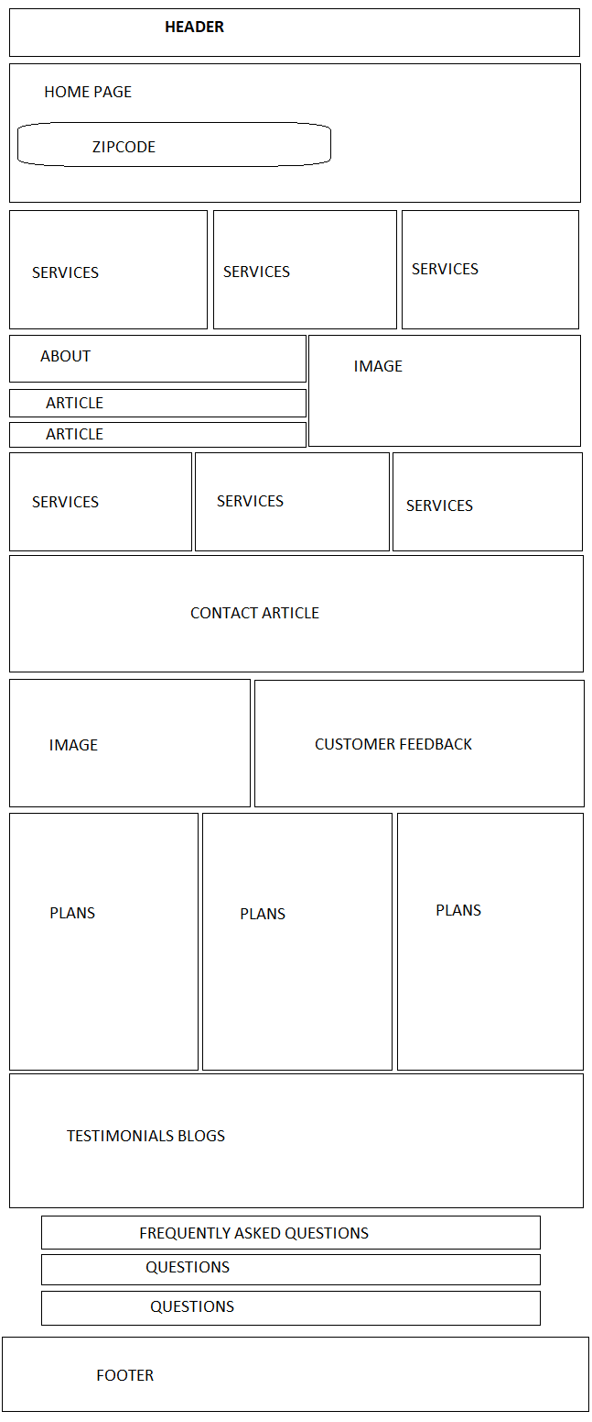

**WIREFRAMES (ABOUT US):**

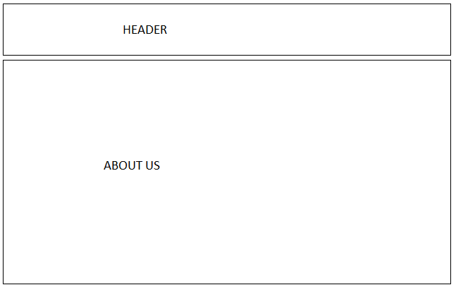

**WIREFRAMES (CONTACT US):**

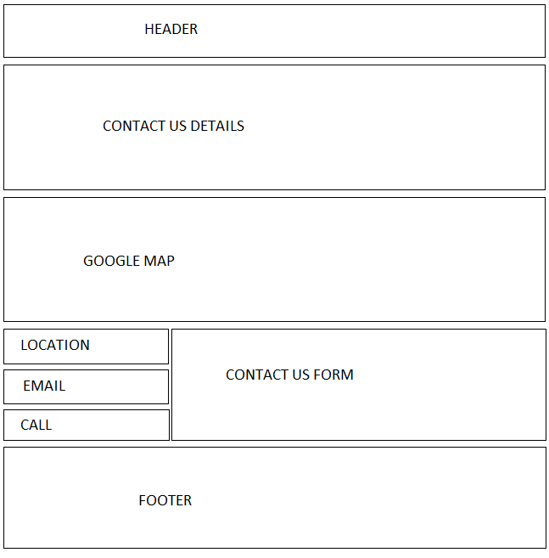

**AGGRIGATED SITEMAP**

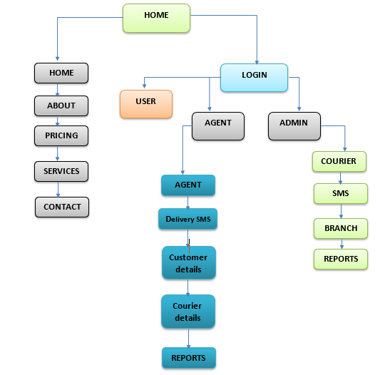

**TASKS**

**Project Start Date:                      08-Jan-2023**

**Project Submission Date:           02-Feb-2023**

|  |  |  |  |  |  |
| --- | --- | --- | --- | --- | --- |
| NO | Task | Date | Days | Teammate | Status |
| 1 | Planning | 14/01/23 | 2 | All | Completed |
| 2 | UI Frontend | 16/01/23 | 4 | Student 2,3,5 | Completed |
| 3 | Backend UI | 20/01/23 | 4 | Student 2,3 | Completed |
| 4 | Backend Functionality | 24/01/23 | 7 | Student 4,1 | Completed |
| 5 | Documentation | 02/02/23 | 3 | Student 3,4 | Completed |

**Regards,  
Whole Team**